
Department of Computer Science and Engineering
ALGORITHMIC PROBLEM-SOLVING HACKATHON (APSH 2026)
PROJECT DOCUMENTATION
Date: 03-10-2026 | Venue: 3rd Floor, A & B Blocks
Field | Details
Project Title | Bi-connectivity Network Analyzer
Team Name / Team No. | Team-06
Year / Semester / Section | II Year B.Tech / 1st Sem / D
Algorithm Paradigm Used | Graph
Programming Language / Tools | Python, FastAPI, React, TypeScript, Vite, React Flow, Pytest
Faculty Mentor
Team Members
S.No | Name of the Student | Roll No. | Role
1 | Himesh Babu Bathula | 25MVCSMR0286 | Team Lead
2 | Sanjeet Kumar Dolai | 25MVCSMR0354 | Presentation & Demo
3 | Moola OmPrakash | 25MVCSMR0331 | Documentation
4 | Mareedu Rakshit | 25MVCSMR0326 | Streamlit UI/visualization

1. Problem Statement

Communication networks consist of multiple interconnected devices such as routers, switches and servers. The failure of a critical device can disconnect parts of the network and reduce its reliability. The problem is to model the communication network as an undirected graph and identify articulation points, connected components and biconnected components using graph algorithms. The system should analyze the topology and provide information about structurally critical devices and network connectivity

2. Objectives

1.Model communication networks using graph data structures.
2.Identify critical devices using articulation-point detection.
3.Determine connected and biconnected components of the network.
4.Provide an interactive visualization and analysis of the network topology.
3. Proposed Approach

The proposed system represents the communication network as an undirected graph using an adjacency-list representation. Depth-First Search (DFS) is used to traverse the graph and calculate discovery and low-link values. These values are used to identify articulation points and biconnected components. Connected-component analysis is also performed to determine independent regions of the network. A React-based interface allows users to construct and visualize the network, while a FastAPI backend performs the graph analysis.

4. Algorithm / Pseudocode

Algorithm: Biconnected Network Analysis

Input:
Set of vertices V
Set of edges E

1. Construct an adjacency-list representation of the graph.
2. Initialize:
discovery[v] = 0
low[v] = 0
parent[v] = NULL
3. For every unvisited vertex:
Perform DFS.
4. During DFS:
Assign discovery time.
Initialize low value.
Explore every adjacent vertex.
5. For every DFS child:
Update the low value of the current vertex.
6. If:
low[child] >= discovery[current]
identify the required articulation condition.
7. Store edges using an edge stack to identify biconnected
components.
8. Perform DFS-based connected-component analysis.
9. Return:
DFS traversal
discovery values
low values
articulation points
connected components
biconnected components
10. Display the results in the dashboard.

5. Complexity Analysis
Give the time and space complexity, with justification.
Complexity | Best Case | Average Case | Worst Case
Time | O(V+E) | O(V+E) | O(V+E)
Space | O(V+E) | O(V+E) | O(V+E)
6. Implementation

The system is implemented using Python and FastAPI for the backend and React with TypeScript and Vite for the frontend. React Flow is used for interactive network visualization. The graph is represented using an adjacency list. The main algorithm modules implement DFS, articulation-point detection, biconnected components and connected components. Pytest is used to test the graph and algorithm implementations.

backend/
├── algorithms/
│ ├── dfs.py
│ ├── articulation.py
│ ├── biconnected.py
│ ├── components.py
│ └── analyzer.py
├── tests/
├── main.py
└── requirements.txt

frontend/
└── src/
├── App.tsx
├── App.css
├── index.css
└── main.tsx

7. Results and Test Cases

The system successfully analyzes user-defined network topologies and identifies critical devices, connected regions and biconnected components. The backend algorithm suite was tested using multiple graph structures including connected graphs, disconnected graphs, chains and cyclic graphs.
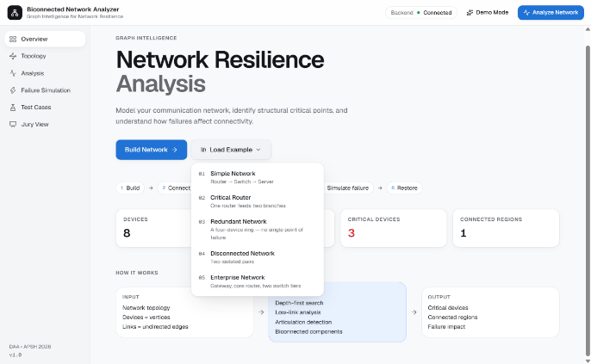
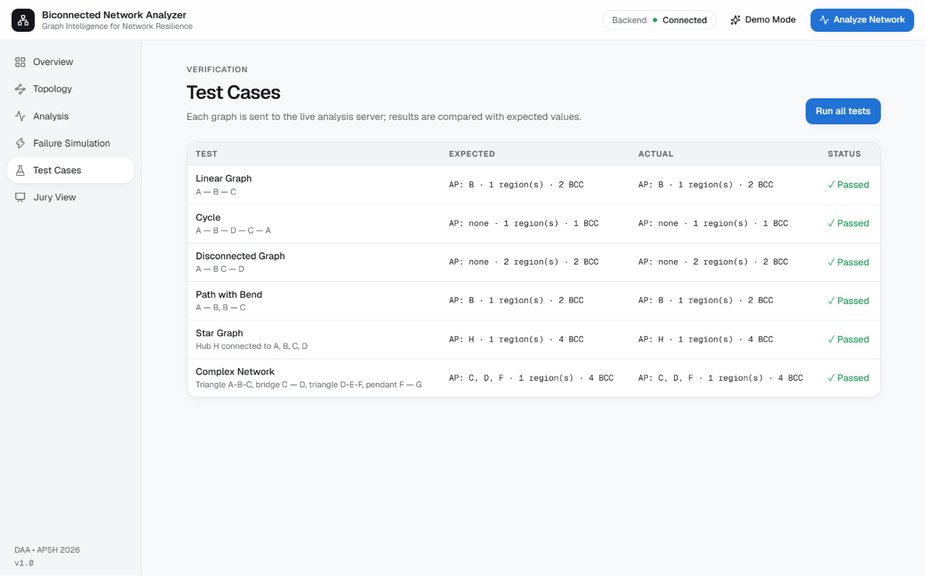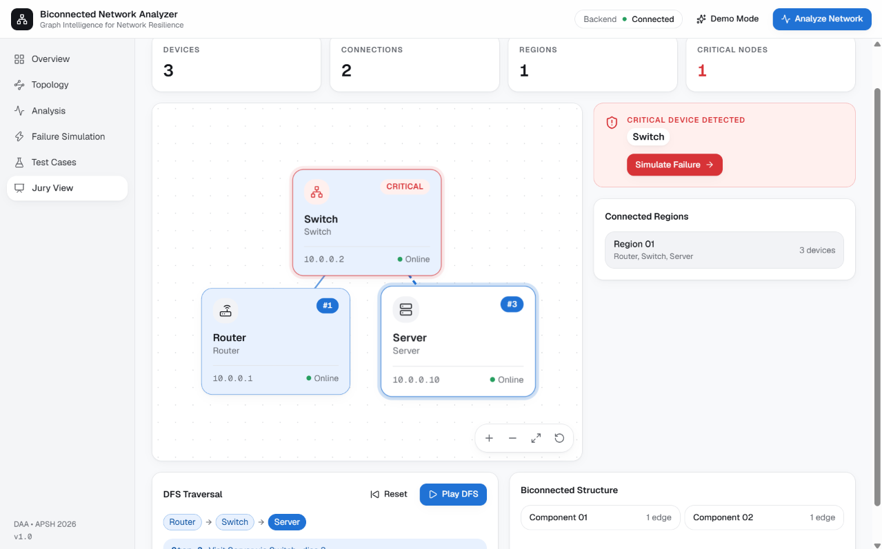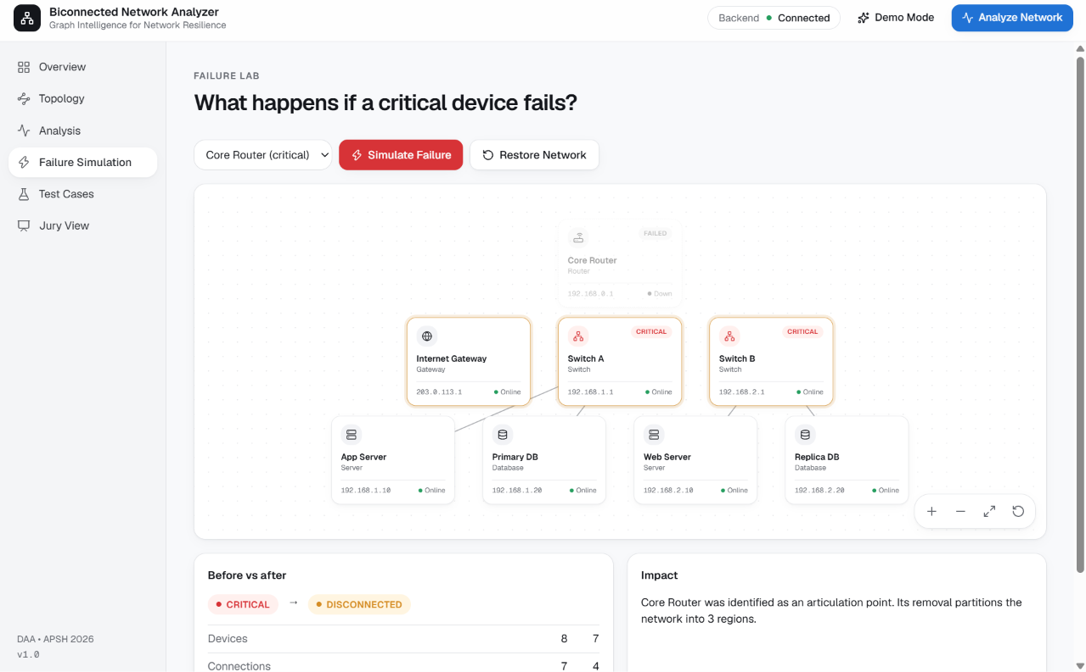

8. Conclusion and Future Scope

The Biconnected Network Analyzer demonstrates the practical application of graph algorithms to communication-network analysis. DFS, articulation-point detection, connected components and biconnected components provide a systematic way to identify structurally critical devices and understand network connectivity.
Future work can include automatic network discovery through SNMP or infrastructure APIs, real-time monitoring, failure simulation, resilience metrics and integration with cloud or enterprise network-management systems.

9. References
- Cormen, T. H., Leiserson, C. E., Rivest, R. L., and Stein, C. Introduction to Algorithms. MIT Press. https://mitpress.mit.edu/9780262046305/introduction-to-algorithms/
- Goodrich, M. T., Tamassia, R., and Goldwasser, M. H. Data Structures and Algorithms in Python. Wiley. https://www.wiley.com/
- Python Software Foundation. Python 3 Documentation. https://docs.python.org/3/
- FastAPI. FastAPI Documentation. https://fastapi.tiangolo.com/
- Meta Open Source. React Documentation. https://react.dev/

